In the world of interior design, the client is at the heart of every project. Whether it's a private home, a corporate office, a retail space, or a hospitality setting, understanding the needs and expectations of the client is critical for the success of the design. However, the concept of "client" in Interior Design extends beyond the individual who commissions the project. There are multiple audiences, stakeholders, and users involved, all of whom influence the design process in various ways. In this article, we will investigate this in more detail:



Fig 1. Pexels (2024) Woman showing a blueprint to a couple

# Audiences, Stakeholders, and Users in Interior Design

1. **Audiences:** The **audience** of an interior design project is the broader group of people who will view, experience, or be influenced by the space. In a commercial setting, this might include customers, visitors, or potential investors. For residential projects, the audience could be extended family members or social guests. Interior Designers will need to consider how the space will resonate with these individuals, even if they aren't directly involved in the design process.
2. **Stakeholders:** Stakeholders are those with a vested interest in the project's outcome. In commercial projects, stakeholders often include investors, business owners, facility managers, and sometimes marketing teams. In public or governmental projects, stakeholders might include city planners, environmental consultants, and community leaders. In a residential Interior Design project, the client will also be the stakeholder. Each of these groups has their own set of priorities and needs that must be considered alongside the desires of the primary client.
3. **Users:** The users are the individuals who will actively inhabit and interact with the space on a daily basis. For example, in a residential design, this could be the homeowners and their families. In an office design, it could be employees and visitors. For retail or hospitality spaces, the users include customers, staff, and vendors. Understanding how these users will engage with the space is essential for creating a functional, comfortable, and aesthetically pleasing environment.

# Types of Client

Interior designers collaborate with a wide array of clients, each with unique needs and objectives. Broadly, these clients can be categorised into three main groups: homeowners, business owners, and property developers/real estate companies. Understanding these client types helps interior designers tailor their services effectively.

#### 1. Homeowners

Homeowners are a significant segment of interior design clients. They seek professional expertise to create comfortable, stylish, and functional spaces that reflect their personal tastes. This group includes:

* **New Homeowners**: Individuals or families looking to personalise their recently purchased homes.
* **Renovators**: Those updating outdated spaces to enhance functionality, aesthetics, or property value.
* **Luxury Clients**: Homeowners with high-end budgets who desire unique, opulent designs.

Homeowners often focus on individual rooms, such as kitchens, living areas, or bedrooms, and will value designs that combine aesthetics with practicality.

#### 2. Business Owners

Business owners engage with interior designers to enhance their commercial spaces, and depending on the nature of the business, they will aim to attract customers and boost productivity or sales (services or product). This group typically includes:

* **Retailers**: Seeking visually appealing and inviting stores to improve customer experience.
* **Hospitality Businesses**: Restaurants, hotels, and cafés. They generally require a style and ambience that aligns with their brand identity.
* **Corporate Offices**: Companies aiming for ergonomic, inspiring, and efficient office layouts to support employees and reflect their corporate image.

For business clients, functionality and branding often take precedence, requiring designers to balance creativity with strategic planning.

#### 3. Property Developers and Real Estate Companies

This group collaborates with interior designers to maximise the appeal and marketability of their properties. They include:

* **Residential Developers**: Designing model homes and apartments to attract potential buyers or renters.
* **Commercial Developers**: Enhancing lobbies, offices, and retail spaces to create competitive properties.
* **Real Estate Stagers**: Preparing properties for sale by showcasing their potential through professional staging.

Property developers and real estate professionals prioritise designs that highlight a property’s strengths and cater to the target audience.

# The Role of the Client in Interior Design

While the audience, stakeholders, and users all play a role in shaping an interior design project, the client is often the most critical figure. The client is typically the individual or group who commissions the project, provides funding, and makes key decisions regarding the design's scope, budget, and timeline. Developing a strong relationship with the client is essential to ensuring a successful outcome.

As an interior designer, being aware of the following aspects can significantly impact your ability to work effectively with clients:

1. **Understanding Client Needs and Expectations:** Every client has a unique set of desires and expectations for their space. Whether it's a specific aesthetic, functional requirements, or emotional connection to certain elements, interior designers must develop a deep understanding of their client's vision. This often involves detailed interviews, questionnaires, and mood boards to capture the essence of the client's goals.



Fig 2. Pexels (nd) People Holding a Floor Tile Samples While on the Floor

1. **Budget and Financial Constraints:** Budget is one of the most important factors in any interior design project. Designers must be aware of the client's financial limitations and propose designs that align with these constraints. It’s crucial to maintain transparency about what can be achieved within the allocated budget and manage expectations accordingly.
2. **Personal Preferences and Emotional Connections:** Clients often have personal tastes and emotional connections to particular design styles, materials, or even individual pieces of furniture. It's important to respect these preferences while also guiding the client toward design solutions that meet both aesthetic and functional needs.
3. **Decision-Making Process:** Some clients may be highly involved in the design process, while others may prefer to leave many decisions to the designer. Understanding the client's preferred level of involvement is essential for fostering a smooth working relationship. Clear communication and setting boundaries early on can help avoid misunderstandings later in the project

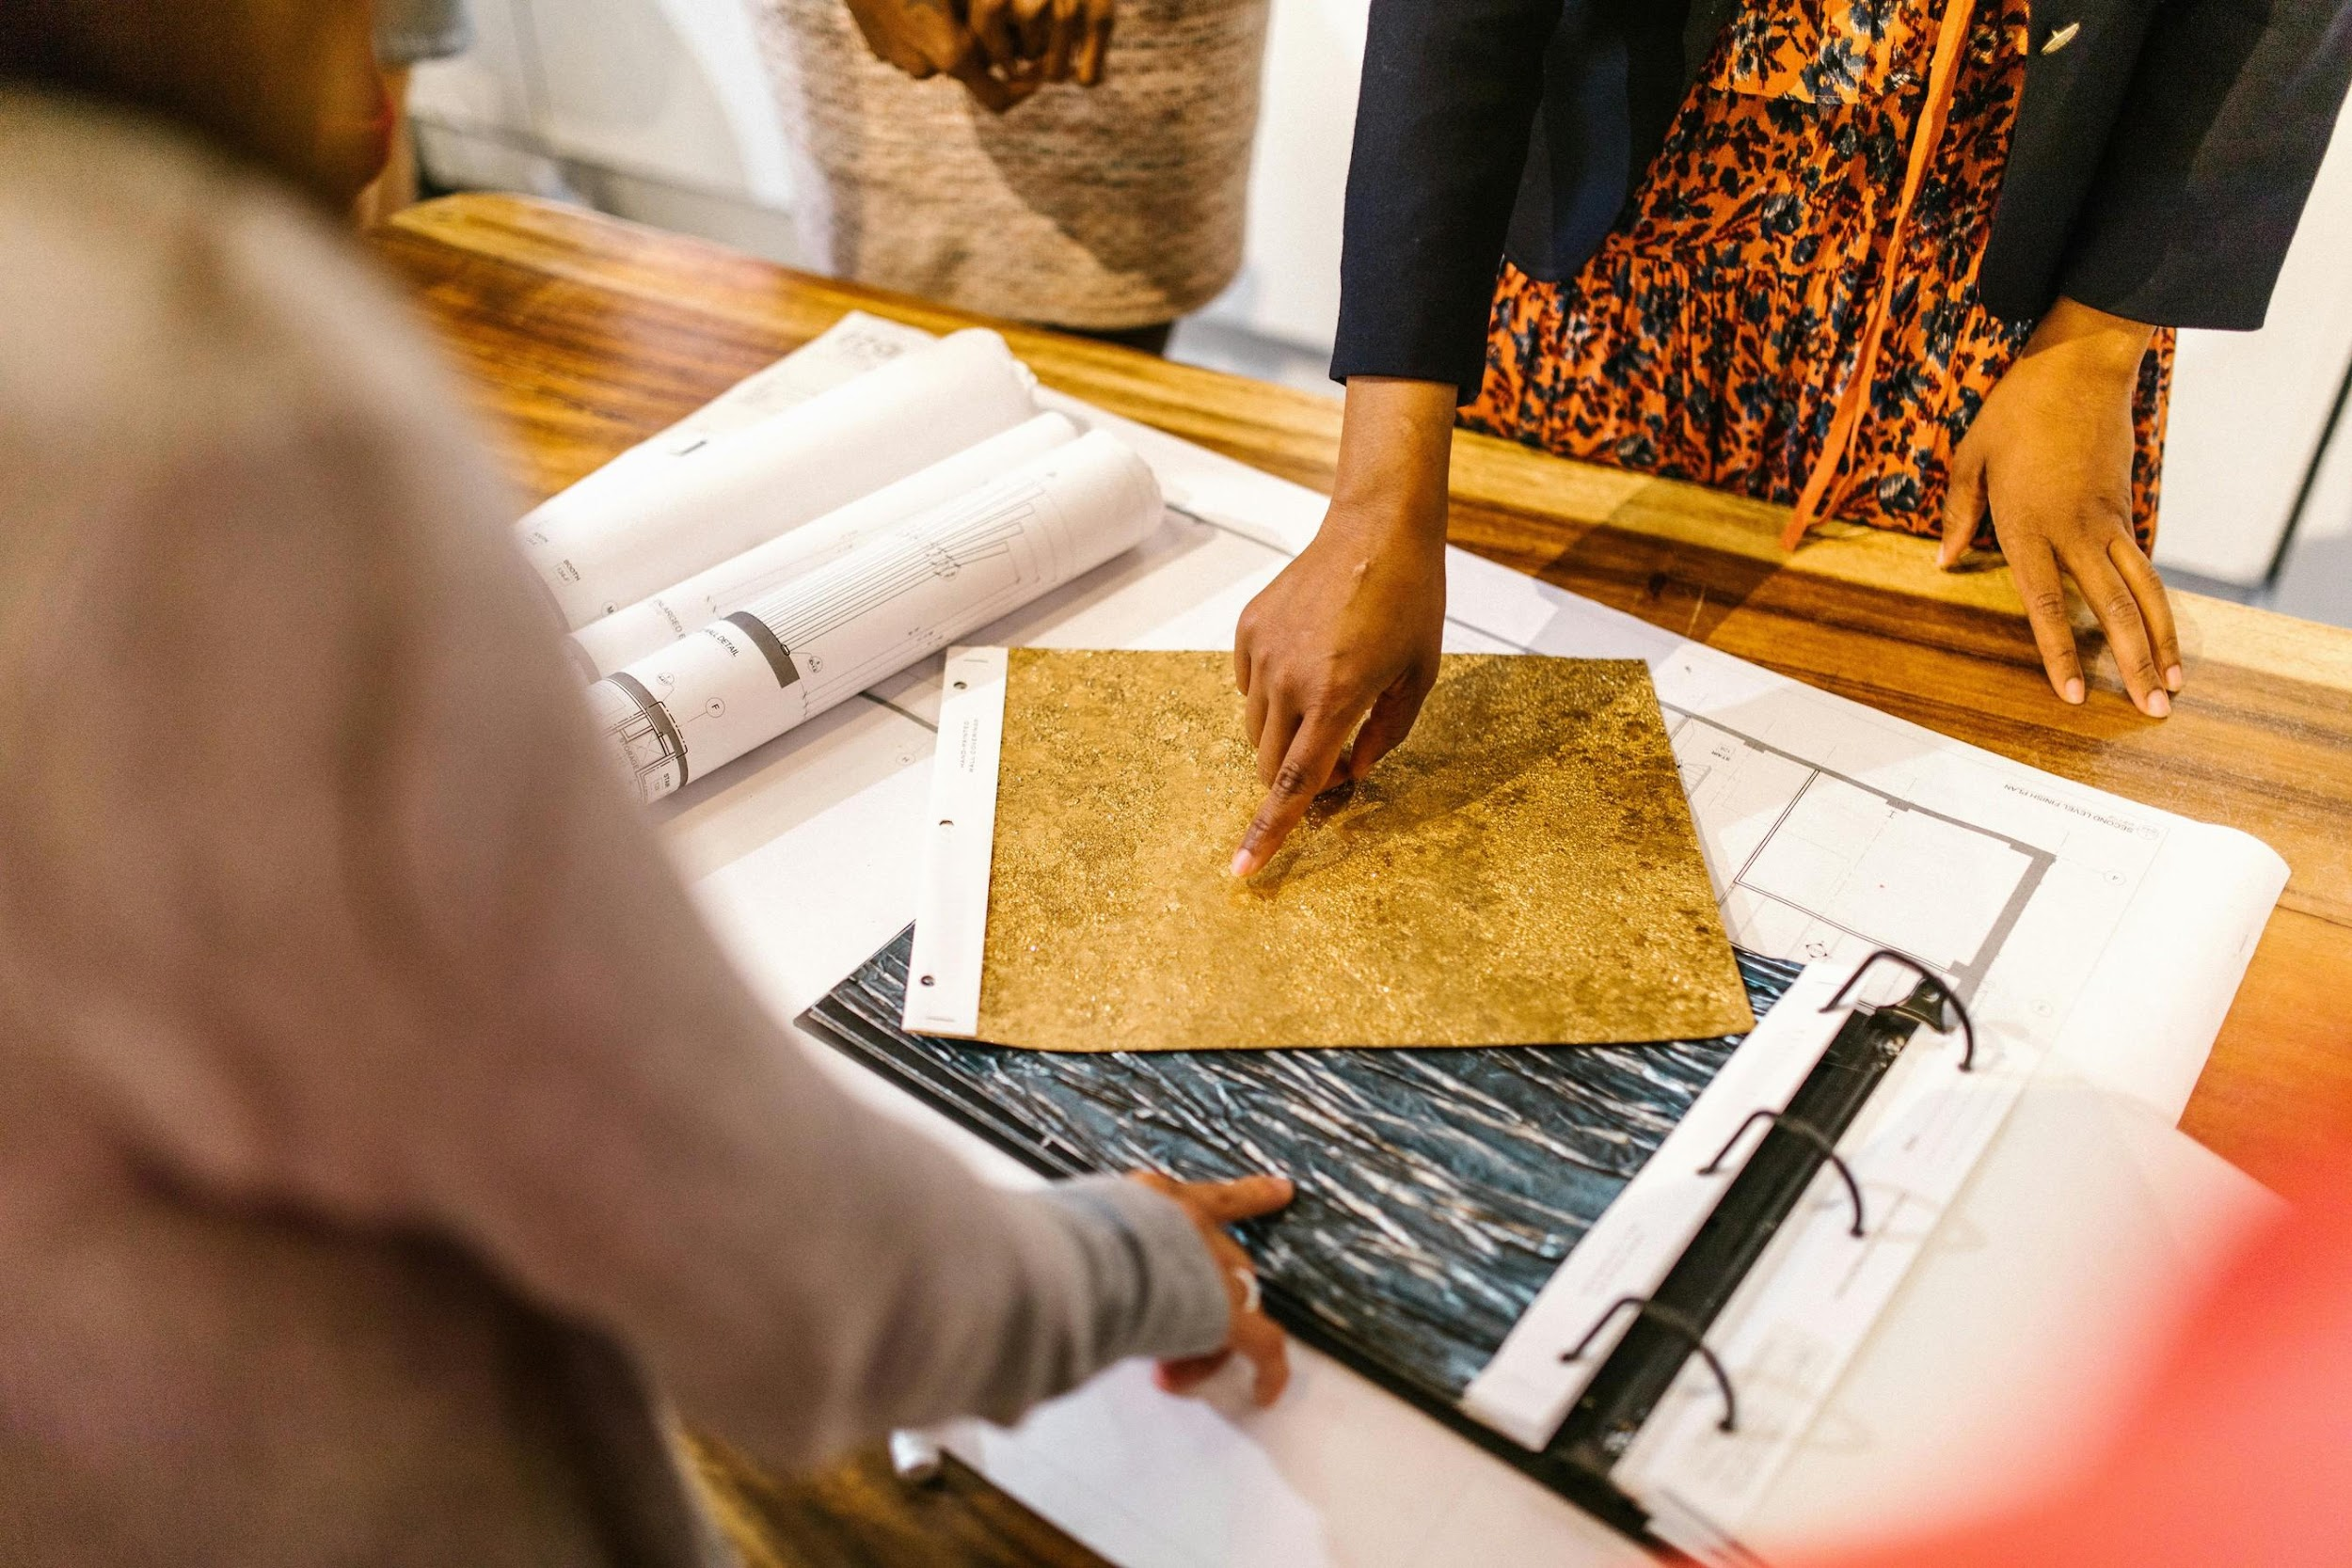

Fig 3. Pexels (nd) Women Pointing Fingers on Material Samples

# Building a Strong Client-Designer Relationship.

The relationship between an interior designer and their client is built on trust, communication, and mutual respect. Here are several techniques to help foster a positive and productive working relationship with clients:

* 1. **Active Listening:** Listening to the client is one of the most important skills an interior designer can have. This means not only hearing what the client says but also understanding the underlying motivations and concerns behind their requests. Active listening helps ensure that the designer can deliver a space that truly meets the client's needs.
  2. **Clear Communication:** Frequent and clear communication is essential for keeping the client informed and involved throughout the design process. Providing regular updates on the project’s progress, sharing visuals like sketches and renderings, and being transparent about any changes in budget or timeline will help build trust with the client.
  3. **Managing Expectations:** Setting realistic expectations from the start is key to avoiding disappointment. Whether it’s about the project's timeline, budget, or the feasibility of certain design choices, being upfront and honest with the client will help maintain a positive relationship throughout the project.
  4. **Collaboration and Flexibility:** Interior design is inherently collaborative. While the designer brings expertise and creativity, the client's vision must be central to the design. Being flexible and willing to adapt to new ideas or feedback will make the client feel more invested in the project and create a stronger partnership.
  5. **Problem-Solving Skills:** Challenges inevitably arise in any design project. Whether it’s delays, budget overruns, or unforeseen structural issues, the ability to problem-solve quickly and effectively is essential. Clients appreciate designers who can offer solutions rather than just presenting problems.



Fig 4. Pexels (nd) Women Talking while the Man is Pointing his Finger on the Hanging Card.

# The Role of Individual Interpretation and Choice in Interior Design

Interior design is an art as much as it is a science, and every designer brings their own interpretation and choices to a project. While the client's needs and desires are the foundation of the design, the designer's creativity, knowledge, and personal style play an equally important role. Striking the right balance between the client’s vision and the designer’s expertise is where true interior design magic happens.

* + 1. **Balancing Personal Style with Client Preferences**: As an interior designer, it’s essential to honour your client’s preferences while infusing the design with your professional expertise.

The goal is to enhance the client’s ideas, sometimes even pushing them beyond their comfort zone to achieve something exceptional. However, it’s important to ensure that the final design is a reflection of the client’s personality and not just the designer's signature style.

* + 1. **Design Choices Informed by Context:** Interior design is influenced by a variety of contextual factors, including the architecture of the space, the environment, and even the cultural or historical significance of the area. The designer's interpretation of these factors plays a significant role in shaping the design. A good designer is able to weave these contextual elements into the design in a way that aligns with the client’s vision.
    2. **Creating Unique, Personalised Spaces:** One of the most satisfying aspects of interior design is the ability to create spaces that are truly unique to each client. By interpreting the client’s needs and desires in creative ways, designers can offer solutions that clients may not have even considered. The result is a space that feels both personal and innovative.

The client is a central figure in any interior design project, but the process is always collaborative, involving a variety of audiences, stakeholders, and users. Building a strong relationship with the client is key to success, and this requires a deep understanding of their needs, clear communication, and the ability to manage expectations. While the client’s vision is essential, the designer’s interpretation and choices bring the project to life, resulting in a space that is functional, aesthetically pleasing, and deeply personal to the client.